EXPERIMENT 25
FFT-Based Beamforming for 5G Wireless Communication Using MATLAB
Lokesh A (192512293)
B.E. Electronics and Communication Engineering (ECE)
Experiment Date: 13 October 2026
AIM
To implement FFT-based spatial spectrum estimation and beamforming for a 5G antenna array operating at 28 GHz, and to compare conventional, Hamming-tapered, and MVDR beamformers in terms of beam steering, interference suppression, and output signal-to-interference-plus-noise ratio (SINR).
OBJECTIVES
- To model an eight-element uniform linear antenna array (ULA) with half-wavelength element spacing.
- To estimate signal arrival directions using the spatial FFT and compare the result with a Capon reference spectrum.
- To steer the main beam towards +20° while considering interferers at −30° and +45°.
- To compare conventional, Hamming-tapered, and minimum-variance distortionless response (MVDR) beamformers.
- To evaluate beam-pattern characteristics and input/output SINR.
SOFTWARE REQUIREMENTS
MATLAB (Base MATLAB functions; Phased Array System Toolbox is not required).
THEORY
Beamforming is a signal-processing technique that combines signals received by multiple antenna elements using suitable complex weights. The weights reinforce signals arriving from a desired direction and can reduce signals arriving from unwanted directions.
For a uniform linear array, the wavelength and inter-element spacing are
λ = c / f_c and d = λ / 2
where c is the speed of light, f_c is the carrier frequency, λ is the wavelength, and d is the spacing between adjacent elements. The array steering vector for arrival angle θ is
a(θ) = [1, e^{jψ}, e^{j2ψ}, …, e^{j(N−1)ψ}]ᵀ, ψ = (2πd/λ) sin θ
The array factor is computed by applying beamformer weights to the steering vector. The conventional beamformer uses uniform weights, the Hamming beamformer applies a taper to reduce sidelobes, and MVDR computes adaptive weights from the received-data covariance matrix.
The output SINR is the ratio of desired-signal power to the combined interference and noise power at the beamformer output, expressed in decibels.
INPUT PARAMETERS
Parameter | Value
Carrier frequency | 28 GHz
Number of antenna elements | 8
Element spacing | λ/2
Desired direction | +20°
Interferer directions | −30° and +45°
Snapshots | 2000
Desired-signal SNR | 10 dB
Interferer INR | 10 dB each
Spatial FFT length | 2048
ALGORITHM
- Initialize the simulation parameters and random-number generator.
- Generate the desired signal, two interfering signals, and complex Gaussian noise at the array elements.
- Calculate the spatial FFT spectrum and the covariance-based Capon reference spectrum.
- Construct conventional, Hamming-tapered, and MVDR beamformer weights.
- Evaluate the array factor for each beamformer and for the selected steering angles.
- Calculate beamwidth, approximate null positions, peak sidelobe level, and input/output SINR.
- Plot the spatial spectrum, beam patterns, steering comparison, and SINR results.
- Display the numerical output parameter table in the MATLAB Command Window.
MATLAB PROGRAM
%% FFT-Based Beamforming for 5G (28 GHz, 8-element ULA)
% Base MATLAB implementation. No Phased Array System Toolbox required.
% Carrier frequency: 28 GHz | Elements: 8 | Spacing: lambda/2
% Desired direction: +20 deg | Interferers: -30 deg and +45 deg
% Save as DSP25.m and run as a script.
%
% Notes:
% - Uses spatial FFT and a Capon/MVDR reference spectrum.
% - The local functions are placed at the end of the script.
% - xline is replaced by plot-based reference lines for compatibility.
clc; clear; close all;
rng(1);
%% 1. INPUT PARAMETERS
fc = 28e9;
c = 3e8;
lambda = c/fc;
N = 8;
d = lambda/2;
thD = 20;
thI = [-30 45];
steerCases = [-30 0 20 45];
K = 2000;
SNRdB = 10;
INRdB = 10;
noiseVar = 1;
Nfft = 2048;
n = (0:N-1).';
a = @(t) exp(1j*n*(2*pi*d/lambda)*sind(t));
th = -90:0.05:90;
A = a(th);
%% 2. ARRAY DATA MODEL
Pd = noiseVar*10^(SNRdB/10);
Pi = noiseVar*10^(INRdB/10);
cg = @(M,L) (randn(M,L) + 1j*randn(M,L))/sqrt(2);
Xd = a(thD)*(sqrt(Pd)*cg(1,K));
Xi = a(thI)*(sqrt(Pi)*cg(numel(thI),K));
Xn = sqrt(noiseVar)*cg(N,K);
X = Xd + Xi + Xn;
%% 3. FFT SPATIAL SPECTRUM AND CAPON REFERENCE
% FFT of the array dimension estimates spatial frequency.
S = fftshift(mean(abs(fft(X,Nfft,1)).^2,2));
f = (-Nfft/2:Nfft/2-1).'/Nfft;
u = f*lambda/d;
u = max(-1,min(1,u)); % protect asind against round-off
thS = asind(u);
SdB = 10*log10(S/max(S) + eps);
R = (X*X')/K;
Rloaded = R + 1e-3*trace(R)/N*eye(N);
Rinv = Rloaded \ eye(N);
denom = real(sum(conj(A).*(Rinv*A),1));
Pcap = 1./max(denom,eps);
CdB = 10*log10(Pcap/max(Pcap) + eps);
pk = top_peaks(SdB,3);
doaFFT = sort(thS(pk)).';
%% 4. BEAMFORMER WEIGHTS
aD = a(thD);
w_conv = conj(aD)/N;
taper = 0.54 - 0.46*cos(2*pi*n/(N-1));
w_hamm = taper.*conj(aD)/sum(taper);
% MVDR weights, conjugated because output/pattern below use non-conjugate transpose.
w_std = (Rloaded\aD)/(aD'*(Rloaded\aD));
w_mvdr = conj(w_std);
AF_conv = 20*log10(abs(w_conv.'*A) + 1e-6);
AF_hamm = 20*log10(abs(w_hamm.'*A) + 1e-6);
AF_mvdr = 20*log10(abs(w_mvdr.'*A) + 1e-6);
% FFT-based evaluation of conventional array factor.
AF_fft = fftshift(ifft(w_conv,Nfft)*Nfft);
AFfftdB = 20*log10(abs(AF_fft) + 1e-6);
%% 5. STEERING CASES
AFsteer = zeros(numel(steerCases),numel(th));
peakAng = zeros(1,numel(steerCases));
for i = 1:numel(steerCases)
w = conj(a(steerCases(i)))/N;
AFsteer(i,:) = 20*log10(abs(w.'*A) + 1e-6);
[~,ix] = max(AFsteer(i,:));
peakAng(i) = th(ix);
end
%% 6. PERFORMANCE METRICS
mC = beam_metrics(th,AF_conv);
mH = beam_metrics(th,AF_hamm);
[~,ipk] = max(AFfftdB);
steerFFT = thS(ipk);
gainAt = @(w,t) 20*log10(abs(w.'*a(t)) + eps);
W = {w_conv,w_hamm,w_mvdr};
names = {'Conventional (FFT)','Hamming taper','MVDR (adaptive)'};
SINR_in = 10*log10(mean(abs(Xd(:)).^2) / ...
(mean(abs(Xi(:)).^2) + mean(abs(Xn(:)).^2)));
SINR_out = zeros(1,3);
for i = 1:3
SINR_out(i) = sinr_db(W{i},Xd,Xi,Xn);
end
%% 7. FIGURE 1: SPATIAL SPECTRUM
figure('Name','Experiment 25A: Spatial Spectrum','Color','w', ...
'Position',[40 40 950 500]);
plot(thS,SdB,'b','LineWidth',1.5); hold on;
plot(th,CdB,'r--','LineWidth',1.1);
yl = [-40 3];
plot([thD thD],yl,'g-','LineWidth',1.2);
plot([thI(1) thI(1)],yl,'k:','LineWidth',1.2);
plot([thI(2) thI(2)],yl,'k:','LineWidth',1.2);
plot(thS(pk),SdB(pk),'bv','MarkerFaceColor','b','MarkerSize',7);
grid on; xlim([-90 90]); ylim(yl);
xlabel('Arrival angle \theta (deg)');
ylabel('Normalised power (dB)');
title('FFT-based spatial spectrum of the 8-element array data');
legend('FFT spatial spectrum','Capon reference','Desired +20 deg', ...
'Interferer -30 deg','Interferer +45 deg','Detected FFT peaks', ...
'Location','southoutside');
%% 8. FIGURE 2: BEAM PATTERN
figure('Name','Experiment 25B: Beam Pattern','Color','w', ...
'Position',[80 80 1150 480]);
subplot(1,2,1);
plot(th,AF_conv,'b','LineWidth',1.5); hold on;
plot(thS(1:25:end),AFfftdB(1:25:end),'ro','MarkerSize',3);
yl = [-50 5];
plot([thD thD],yl,'g-','LineWidth',1.2);
plot([thI(1) thI(1)],yl,'k:','LineWidth',1.2);
plot([thI(2) thI(2)],yl,'k:','LineWidth',1.2);
grid on; xlim([-90 90]); ylim(yl);
xlabel('\theta (deg)'); ylabel('|AF| (dB)');
title(sprintf('Beam steered to %d deg (FFT peak %.1f deg)',thD,steerFFT));
legend('Direct array-factor formula','FFT-based array factor', ...
'Desired direction','Interference directions','Location','southoutside');
subplot(1,2,2);
polarplot(deg2rad(th),max(AF_conv,-50),'b','LineWidth',1.4); hold on;
pax = gca;
pax.ThetaZeroLocation = 'top';
pax.ThetaDir = 'clockwise';
thetalim([-90 90]); rlim([-50 0]);
polarplot(deg2rad([thD thD]),[-50 0],'g','LineWidth',1.2);
polarplot(deg2rad([thI(1) thI(1)]),[-50 0],'k:','LineWidth',1.2);
polarplot(deg2rad([thI(2) thI(2)]),[-50 0],'k:','LineWidth',1.2);
title('Polar beam pattern (dB)');
%% 9. FIGURE 3: BEAM STEERING COMPARISON
figure('Name','Experiment 25C: Beam Steering','Color','w', ...
'Position',[120 120 950 480]);
plot(th,AFsteer.','LineWidth',1.5);
grid on; xlim([-90 90]); ylim([-50 5]);
xlabel('\theta (deg)'); ylabel('|AF| (dB)');
title('Beam steering using phase-shift weights');
legend(arrayfun(@(s)sprintf('Steer %d deg',s),steerCases, ...
'UniformOutput',false),'Location','southoutside');
%% 10. FIGURE 4: INTERFERENCE SUPPRESSION AND SINR
figure('Name','Experiment 25D: Interference Suppression','Color','w', ...
'Position',[160 160 1150 480]);
subplot(1,2,1);
plot(th,AF_conv,'b','LineWidth',1.4); hold on;
plot(th,AF_hamm,'m','LineWidth',1.4);
plot(th,AF_mvdr,'r','LineWidth',1.4);
yl = [-70 5];
plot([thD thD],yl,'g-','LineWidth',1.2);
plot([thI(1) thI(1)],yl,'k:','LineWidth',1.2);
plot([thI(2) thI(2)],yl,'k:','LineWidth',1.2);
grid on; xlim([-90 90]); ylim(yl);
xlabel('\theta (deg)'); ylabel('|AF| (dB)');
title('Beam patterns of three beamformers');
legend(names,'Location','southoutside');
subplot(1,2,2);
bar([SINR_in SINR_out]); grid on;
set(gca,'XTick',1:4,'XTickLabel', ...
{'Input','Conventional','Hamming','MVDR'});
ylabel('SINR (dB)'); title('Input and output SINR');
v = [SINR_in SINR_out];
for i = 1:4
text(i,v(i)+0.6,sprintf('%.1f',v(i)), ...
'HorizontalAlignment','center');
end
%% 11. OUTPUT PARAMETER TABLE
fprintf('\n================ SETUP ================\n');
fprintf('Carrier frequency : %.0f GHz\n',fc/1e9);
fprintf('Wavelength : %.3f mm\n',lambda*1e3);
fprintf('Element spacing : %.3f mm\n',d*1e3);
fprintf('Number of elements : %d\n',N);
fprintf('Desired direction : %d deg\n',thD);
fprintf('Interferer directions : %d deg and %d deg\n',thI(1),thI(2));
fprintf('Desired SNR : %d dB\n',SNRdB);
fprintf('Interferer INR : %d dB each\n',INRdB);
fprintf('\n=========== OUTPUT PARAMETER TABLE ===========\n');
fprintf('FFT detected peak angles (deg): %s\n',mat2str(round(doaFFT,1)));
fprintf('True source directions (deg) : %s\n',mat2str(sort([thD thI])));
fprintf('Conventional beam peak : %.2f deg (target %d deg)\n',mC.peak,thD);
fprintf('Peak from FFT beam pattern : %.2f deg\n',steerFFT);
fprintf('\n--- Beam pattern characteristics ---\n');
fprintf('%-22s %-12s %-24s %-12s\n', ...
'Beamformer','HPBW (deg)','Approx. nulls (deg)','PSLL (dB)');
fprintf('%-22s %-12.2f [%6.2f, %6.2f] %-12.2f\n', ...
names{1},mC.hpbw,mC.nulls(1),mC.nulls(2),mC.psl);
fprintf('%-22s %-12.2f [%6.2f, %6.2f] %-12.2f\n', ...
names{2},mH.hpbw,mH.nulls(1),mH.nulls(2),mH.psl);
fprintf('\n--- Steering cases ---\n');
for i = 1:numel(steerCases)
fprintf('Command %4d deg -> peak at %6.2f deg\n', ...
steerCases(i),peakAng(i));
end
fprintf('\n--- Array response (dB) at source directions ---\n');
fprintf('%-22s %-14s %-14s %-14s\n', ...
'Beamformer','Desired +20','Interferer -30','Interferer +45');
for i = 1:3
fprintf('%-22s %-14.2f %-14.2f %-14.2f\n',names{i}, ...
gainAt(W{i},thD),gainAt(W{i},thI(1)),gainAt(W{i},thI(2)));
end
fprintf('\n--- SINR results ---\n');
fprintf('Input SINR (per element): %.2f dB\n',SINR_in);
for i = 1:3
fprintf('%-22s: %.2f dB (change %.2f dB)\n', ...
names{i},SINR_out(i),SINR_out(i)-SINR_in);
end
fprintf('\nRESULT: FFT-based spatial spectrum, beam steering, beamformer comparison, and SINR analysis completed.\n');
%% LOCAL FUNCTIONS
function idx = top_peaks(y,num)
y = y(:);
if numel(y) < 3
idx = (1:numel(y)).';
return;
end
loc = find(y(2:end-1) > y(1:end-2) & ...
y(2:end-1) >= y(3:end)) + 1;
if isempty(loc)
[~,order] = sort(y,'descend');
idx = order(1:min(num,numel(order)));
return;
end
[~,order] = sort(y(loc),'descend');
idx = loc(order(1:min(num,numel(loc))));
end
function m = beam_metrics(th,dB)
dB = dB - max(dB);
[~,ip] = max(dB);
% Half-power beamwidth, using the -3 dB crossings.
left = ip;
while left > 1 && dB(left) >= -3
left = left - 1;
end
right = ip;
while right < numel(th) && dB(right) >= -3
right = right + 1;
end
m.hpbw = th(right) - th(left);
% Approximate first local minima on either side of the main peak.
ln = ip;
while ln > 2 && dB(ln-1) <= dB(ln)
ln = ln - 1;
end
rn = ip;
while rn < numel(th)-1 && dB(rn+1) <= dB(rn)
rn = rn + 1;
end
m.nulls = [th(ln) th(rn)];
side = dB;
side(max(1,ln):min(numel(th),rn)) = -Inf;
m.psl = max(side);
m.peak = th(ip);
end
function s = sinr_db(w,Xd,Xi,Xn)
Ps = mean(abs(w.'*Xd).^2);
Pint = mean(abs(w.'*Xi).^2);
Pn = mean(abs(w.'*Xn).^2);
s = 10*log10(Ps/(Pint + Pn + eps));
end
OUTPUT / OBSERVATIONS
The MATLAB run generated four figures: (1) FFT spatial spectrum with the Capon reference, (2) conventional beam pattern with polar representation, (3) steering-angle comparison, and (4) interference-suppression patterns with input/output SINR.
From the supplied run screenshots, the detected FFT peaks were approximately −30°, 20.2°, and 44.8°, close to the configured source directions of −30°, +20°, and +45°. The conventional beam peak was 20.00°, and the FFT-based beam-pattern peak was about 19.99°.
The displayed output SINR values were approximately −3.14 dB at the input, 11.06 dB for the conventional beamformer, 11.95 dB for the Hamming taper, and 17.94 dB for MVDR. These values correspond to the shown simulation run and may vary if the random seed or parameters are changed.

Figure 1. FFT-based spatial spectrum and detected arrival-angle peaks.
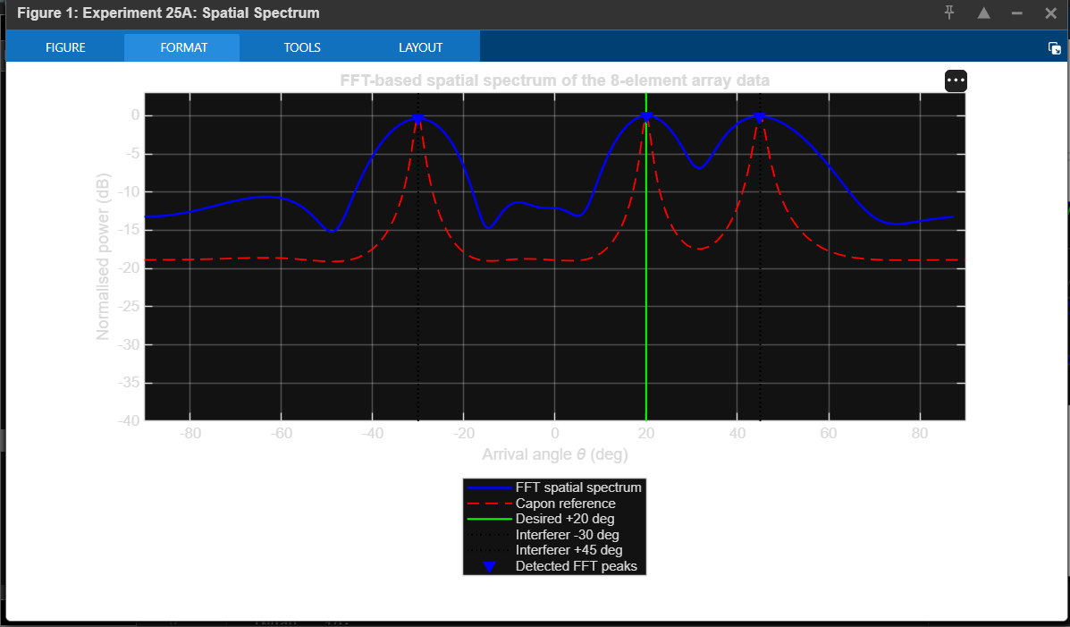

Figure 2. Beam pattern and polar beam-pattern representation.
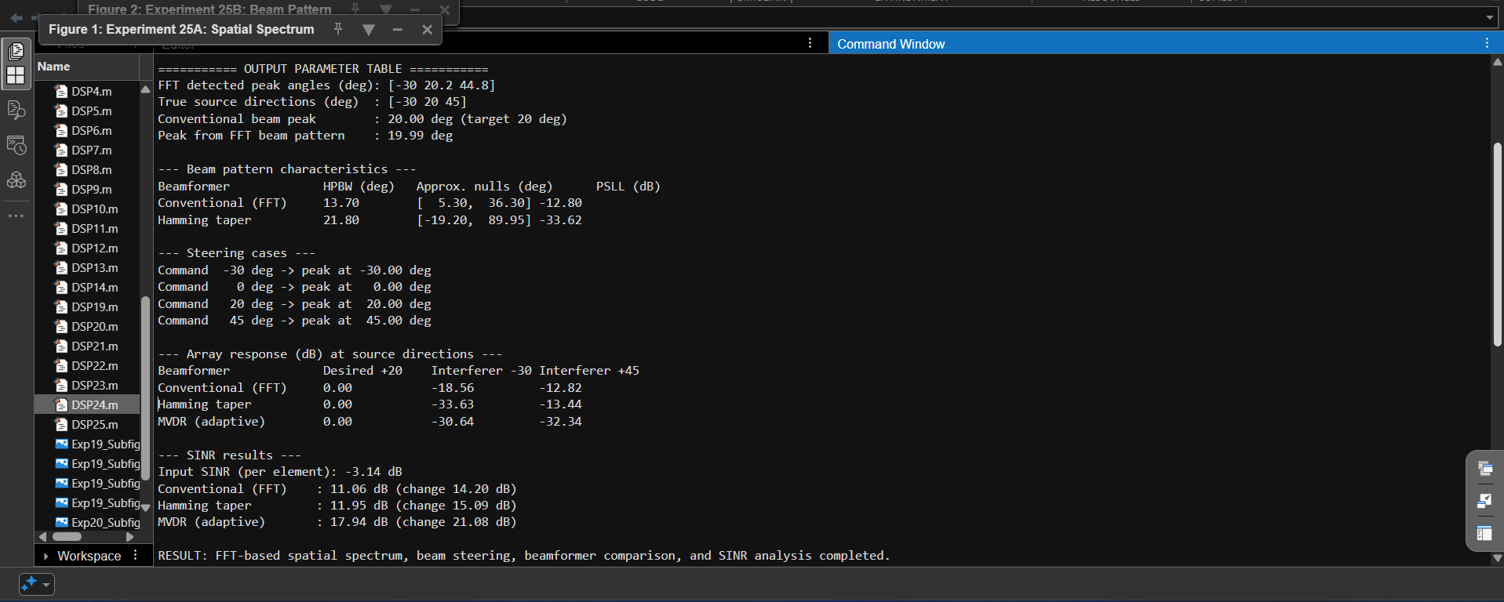

Figure 3. Interference suppression and input/output SINR.
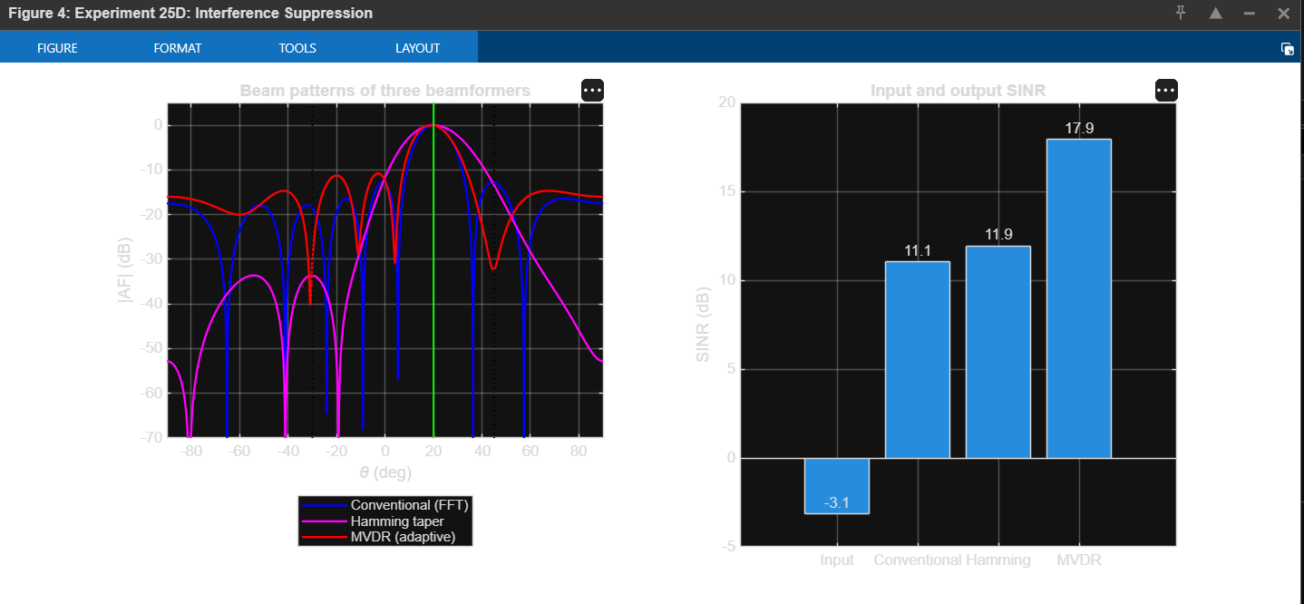

Figure 4. Beam steering comparison for four steering angles.
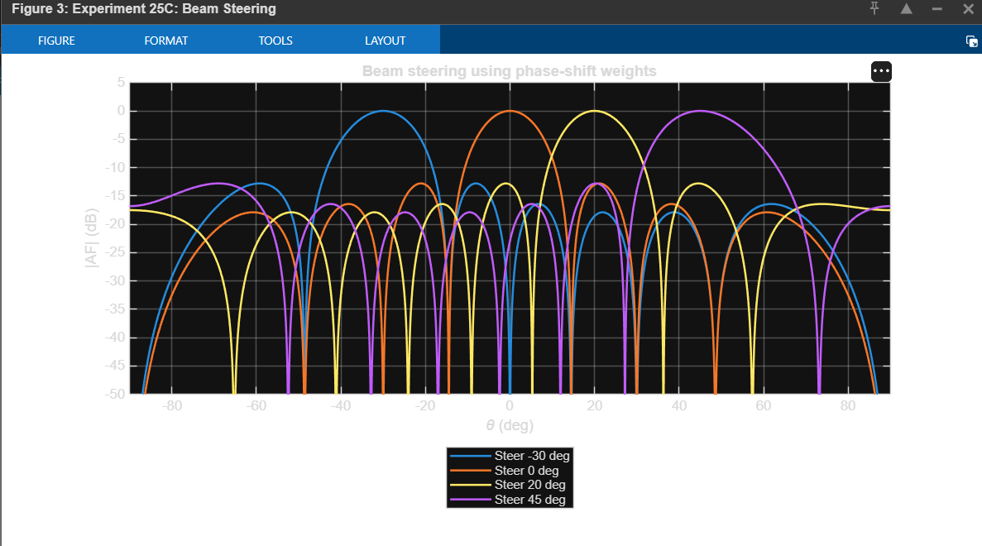

Figure 5. MATLAB output parameter table and simulation results.
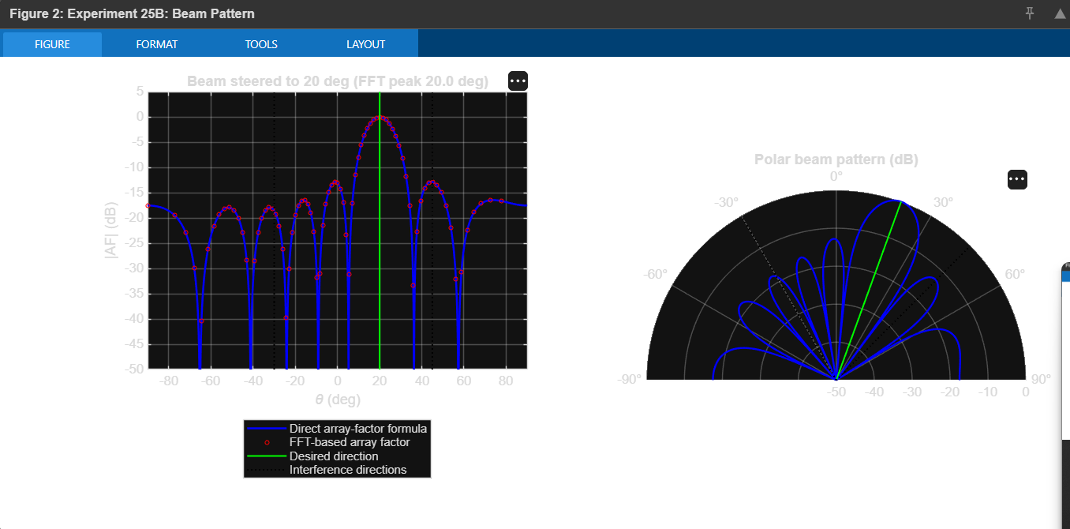
RESULT
FFT-based beamforming for a 5G antenna array was implemented in MATLAB. The simulation estimated the arrival directions, steered the main beam to +20°, compared conventional, Hamming-tapered, and MVDR beamformers, and evaluated interference suppression and SINR. In the supplied run, MVDR produced the highest output SINR among the three evaluated beamformers.
CONCLUSION
The experiment demonstrates spatial spectrum estimation and beam steering using an eight-element uniform linear array at 28 GHz. The results illustrate how antenna weighting affects the main lobe, sidelobes, interference response, and output SINR. The adaptive MVDR approach achieved the strongest interference-plus-noise suppression in the displayed simulation.

